# Symmetric VS Asymmetric Cryptosystem

|  |  |
| --- | --- |
| Symmetric Key Encryption | Asymmetric Key Encryption |
| It only requires a single key for both encryption and decryption. | It requires two keys, a public key and a private key, one to encrypt and the other one to decrypt. |
| The size of cipher text is the same or smaller than the original plain text. | The size of cipher text is the same or larger than the original plain text. |
| The encryption process is very fast. | The encryption process is slow. |
| It only provides confidentiality. | It provides confidentiality, authenticity, and non-repudiation. |
| The length of key used is 128 or 256 bits | The  length of key used is 2048 or higher |
| In symmetric key encryption, resource utilization is low as compared to asymmetric key encryption. | In asymmetric key encryption, resource utilization is high. |
| The Mathematical Representation is as follows- P = D (K, E(P))  where K –> encryption and decryption key P –> plain text D –> Decryption  E(P) –> Encryption of plain text | The Mathematical Representation is as follows- P = D(Kd, E (Ke,P)) where Ke –> encryption key  Kd –> decryption key D –> Decryption E(Ke, P) –> Encryption of plain text using encryption key Ke . P –> plain text |
| Examples: 3DES, AES, DES and RC4 | Examples: Diffie-Hellman, ECC, El Gamal, DSA and RSA |

# Stream Cipher

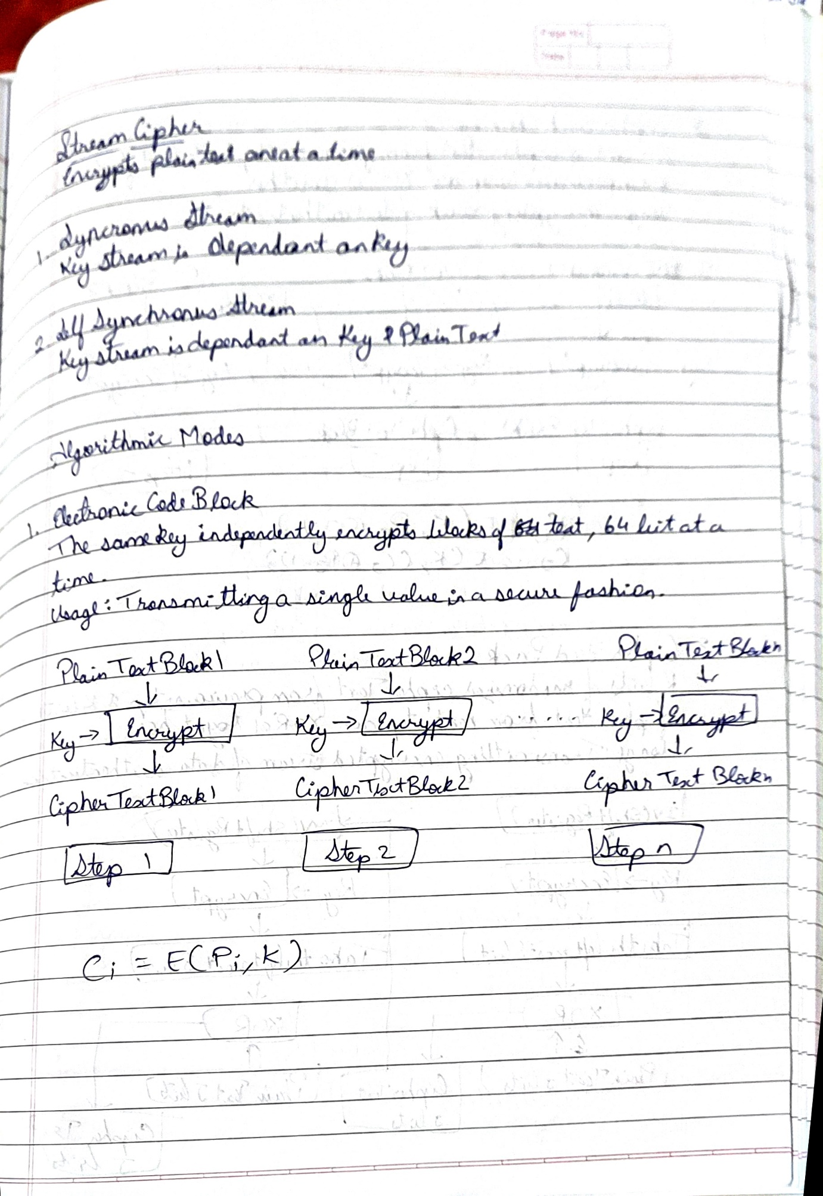

# Synchronous n Self Synchronous Stream Cipher

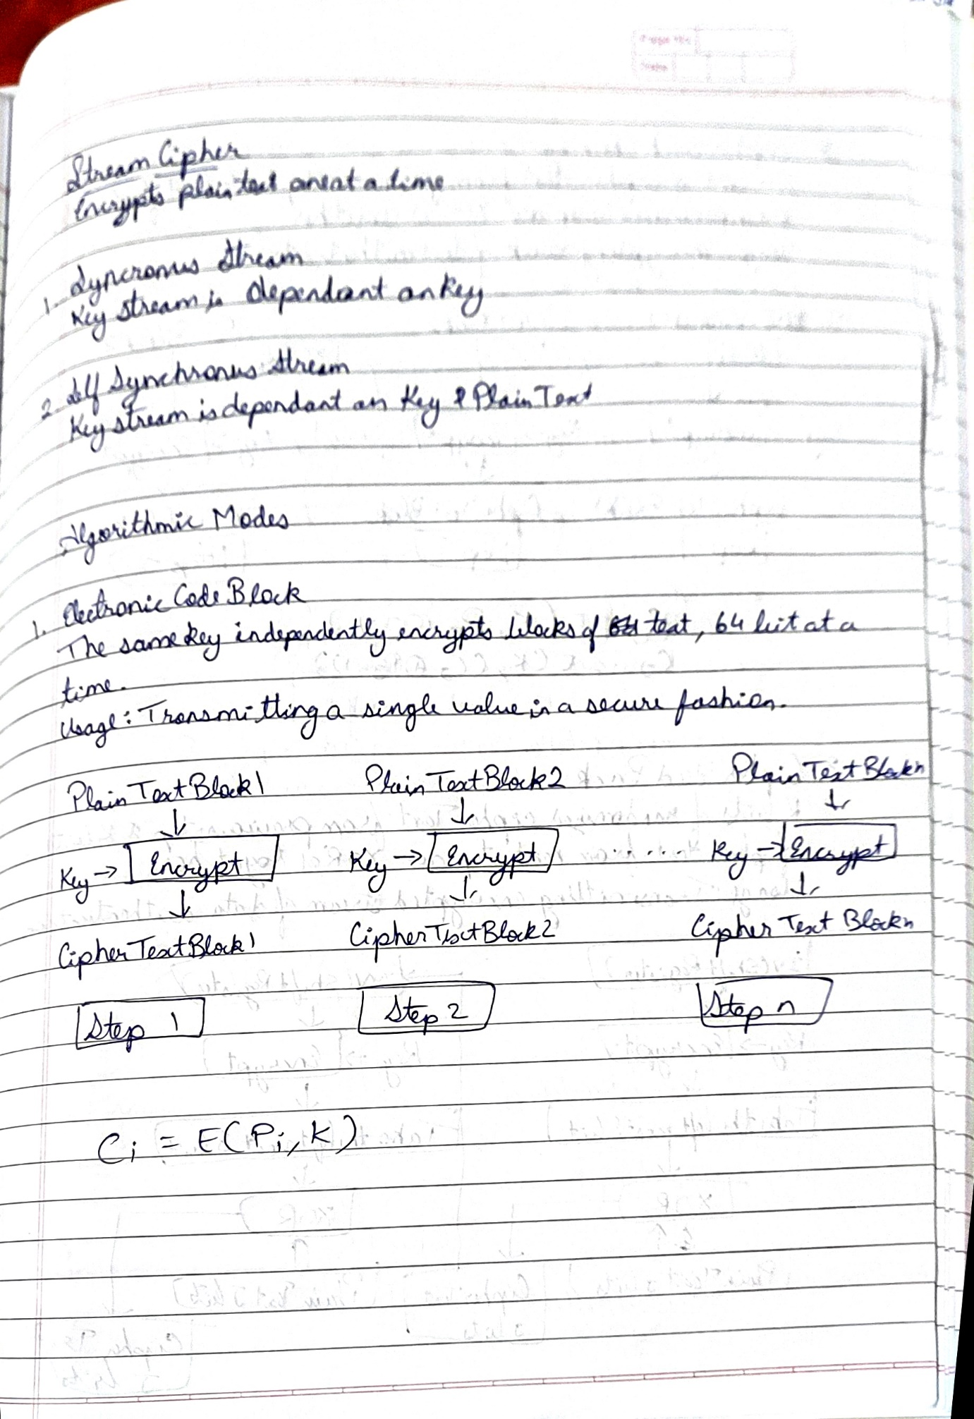

# Algorithmic Modes

## Electronic Code Block

The simplest mode is the electronic codebook (ECB ) mode, in which plaintext is handled one block at a time and each block of plaintext is encrypted using the same key (Figure 7.3). The term codebook is used because, for a given key, there is a unique ciphertext for every b -bit block of plaintext. Therefore, we can imagine a gigantic codebook in which there is an entry for every possible b -bit plaintext pattern showing its corresponding ciphertext.



## Cipher Block Chaining

To overcome the security deficiencies of ECB, we would like a technique in which the same plaintext block, if repeated, produces different ciphertext blocks. A simple way to satisfy this requirement is the cipher block chaining (CBC ) mode (Figure 7.4). In this scheme, the input to the encryption algorithm is the XOR of the current plaintext block and the preceding ciphertext block; the same key is used for each block. In effect, we have chained together the processing of the sequence of plaintext blocks. The input to the encryption function for each plaintext block bears no fixed relationship to the plaintext block. Therefore, repeating patterns of b bits are not exposed. As with the ECB mode, the CBC mode requires that the last block be padded to a full b bits if it is a partial block.

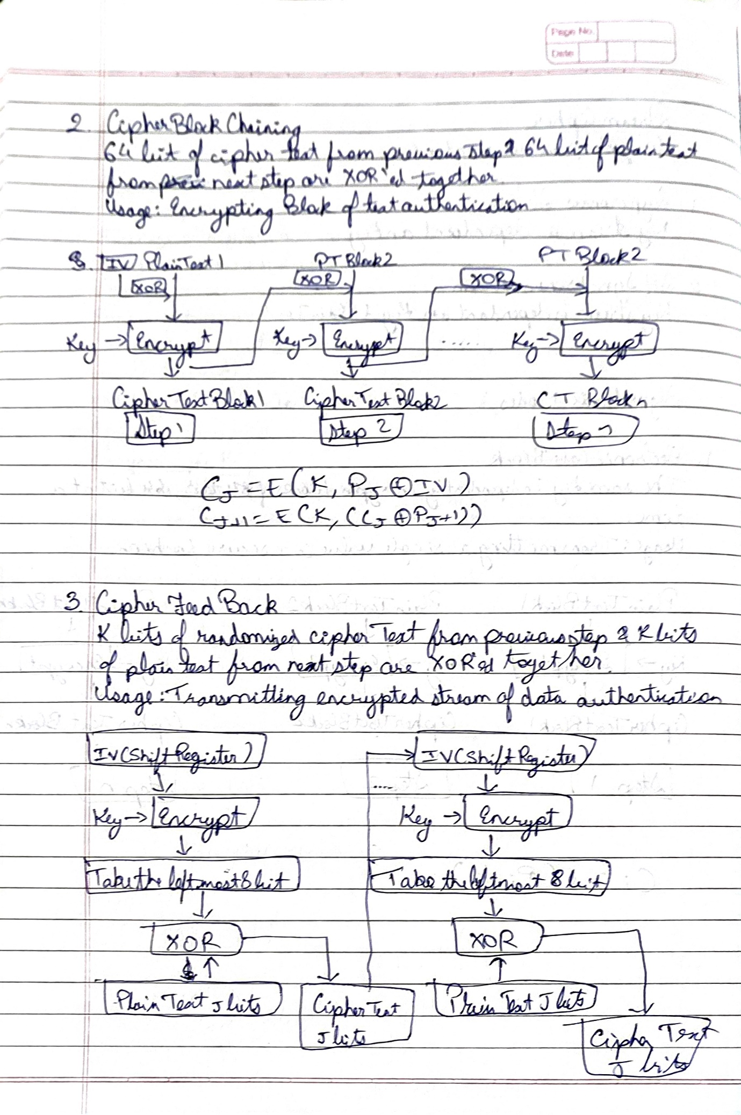

## Cipher Feed Back

First, consider encryption. The input to the encryption function is a b -bit shift register that is initially set to some initialization vector (IV). The leftmost (most significant) s bits of the output of the encryption function are XORed with the first segment of plaintext P1 to produce the first unit of ciphertext C1 , which is then transmitted. In addition, the contents of the shift register are shifted left by s bits, and C1 is placed in the rightmost (least significant) s bits of the shift register. This process continues until all plaintext units have been encrypted.

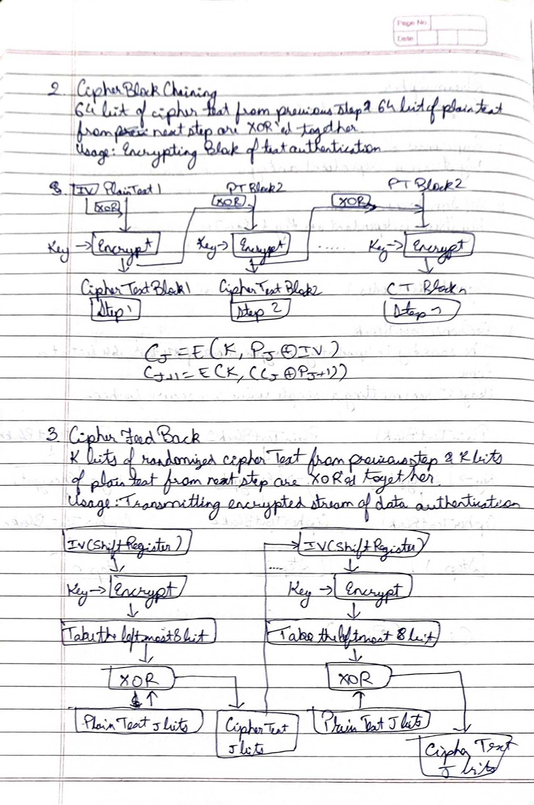

## Output Feedback Mode

As with CBC and CFB, the OFB mode requires an initialization vector. In the case of OFB, the IV must be a nonce; that is, the IV must be unique to each execution of the encryption operation. The reason for this is that the sequence of encryption output blocks, Oi , depends only on the key and the IV and does not depend on the plaintext. Therefore, for a given key and IV, the stream of output bits used to XOR with the stream of plaintext bits is fixed. If two different messages had an identical block of plaintext in the identical position, then an attacker would be able to determine that portion of the Oi stream.

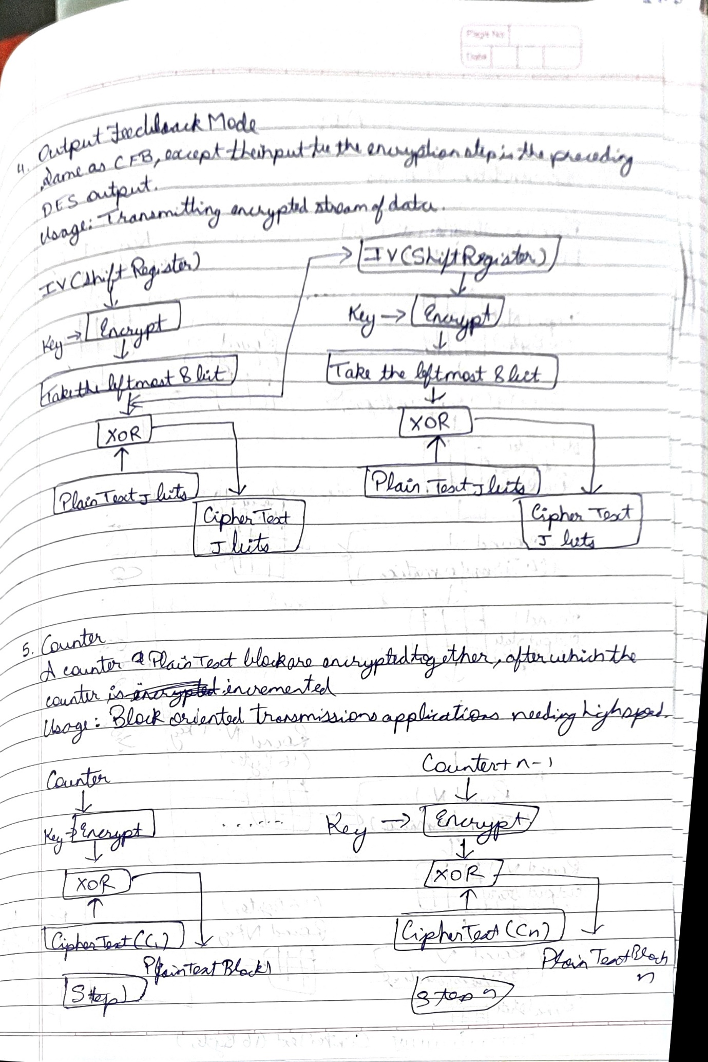

## Counter Mode

Typically, the counter is initialized to some value and then incremented by 1 for each subsequent block (modulo 2b , where b is the block size). For encryption, the counter is encrypted and then XORed with the plaintext block to produce the ciphertext block; there is no chaining. For decryption, the same sequence of counter values is used, with each encrypted counter XORed with a ciphertext block to recover the corresponding plaintext block. Thus, the initial counter value must be made available for decryption.



|  |  |  |  |  |
| --- | --- | --- | --- | --- |
| Feature | ECB | CBC | CFB | OFB/Counter |
| Security-related problems | Plain text patterns are not hidden. Input to the block cipher is the same as the plain text, and is not randomized. Plain text is easy to manipulate, blocks of text can be re- moved, repeated, or exchanged. | Plain-text blocks can be removed from the beginning and end of the message, and bits of the first block can be altered. | Plain-text blocks can be removed from the beginning and end of the message, and bits of the first block can be altered. | Plain text is easy to manipulate. Alter- ing cipher text alters plain text directly. |
| Security-related advantages | The same key can be used for encrypting multiple messages. | XOR of plain text with previous ci- pher-text block hides the plain text. The same key can be used for encrypting multiple messages. | Plain-text patterns are hidden. The same key can be used for encrypting multiple messages, by using a different IV. Input to the block ci- pher is randomized. | Plain-text patterns are hidden. The same key can be used for encrypting multiple messages, by using a different IV. Input to the block ci- pher is randomized. |
| Problems related to effectiveness | Size of cipher text is more than the plain- text size by one pad- ding block. | Size of cipher text is more than the plain text size by one block. | Size of cipher text is the same as that of the plain-text size. | Size of cipher text is the same as that of the plain-text size. |
|  | Pre-processing is not possible. | Pre-processing is not possible. Parallelism cannot be introduced in en- cryption. | Parallelism cannot be introduced in en- cryption. | Parallelism cannot be introduced (OFB only). |

# AES

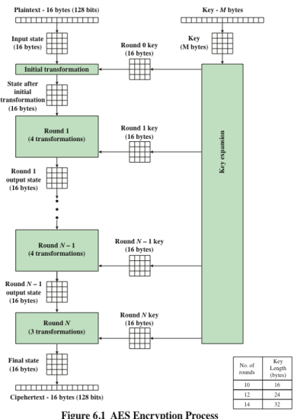

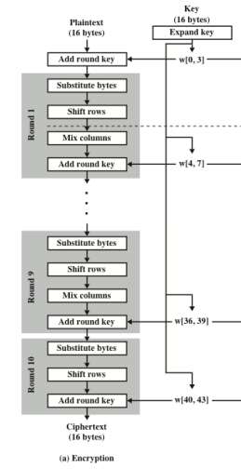

## S Box

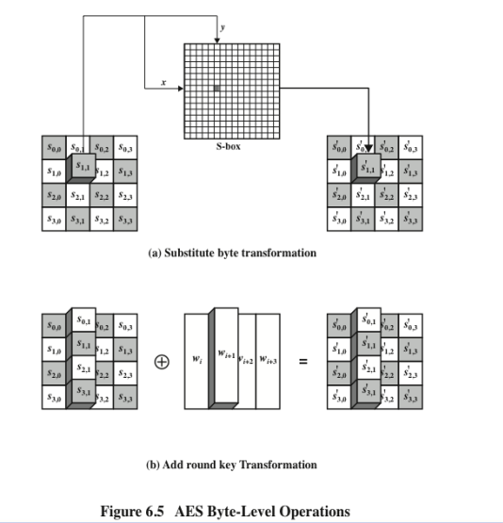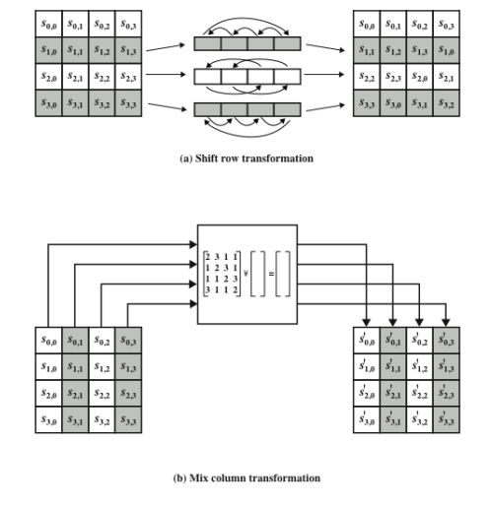

El Gamal 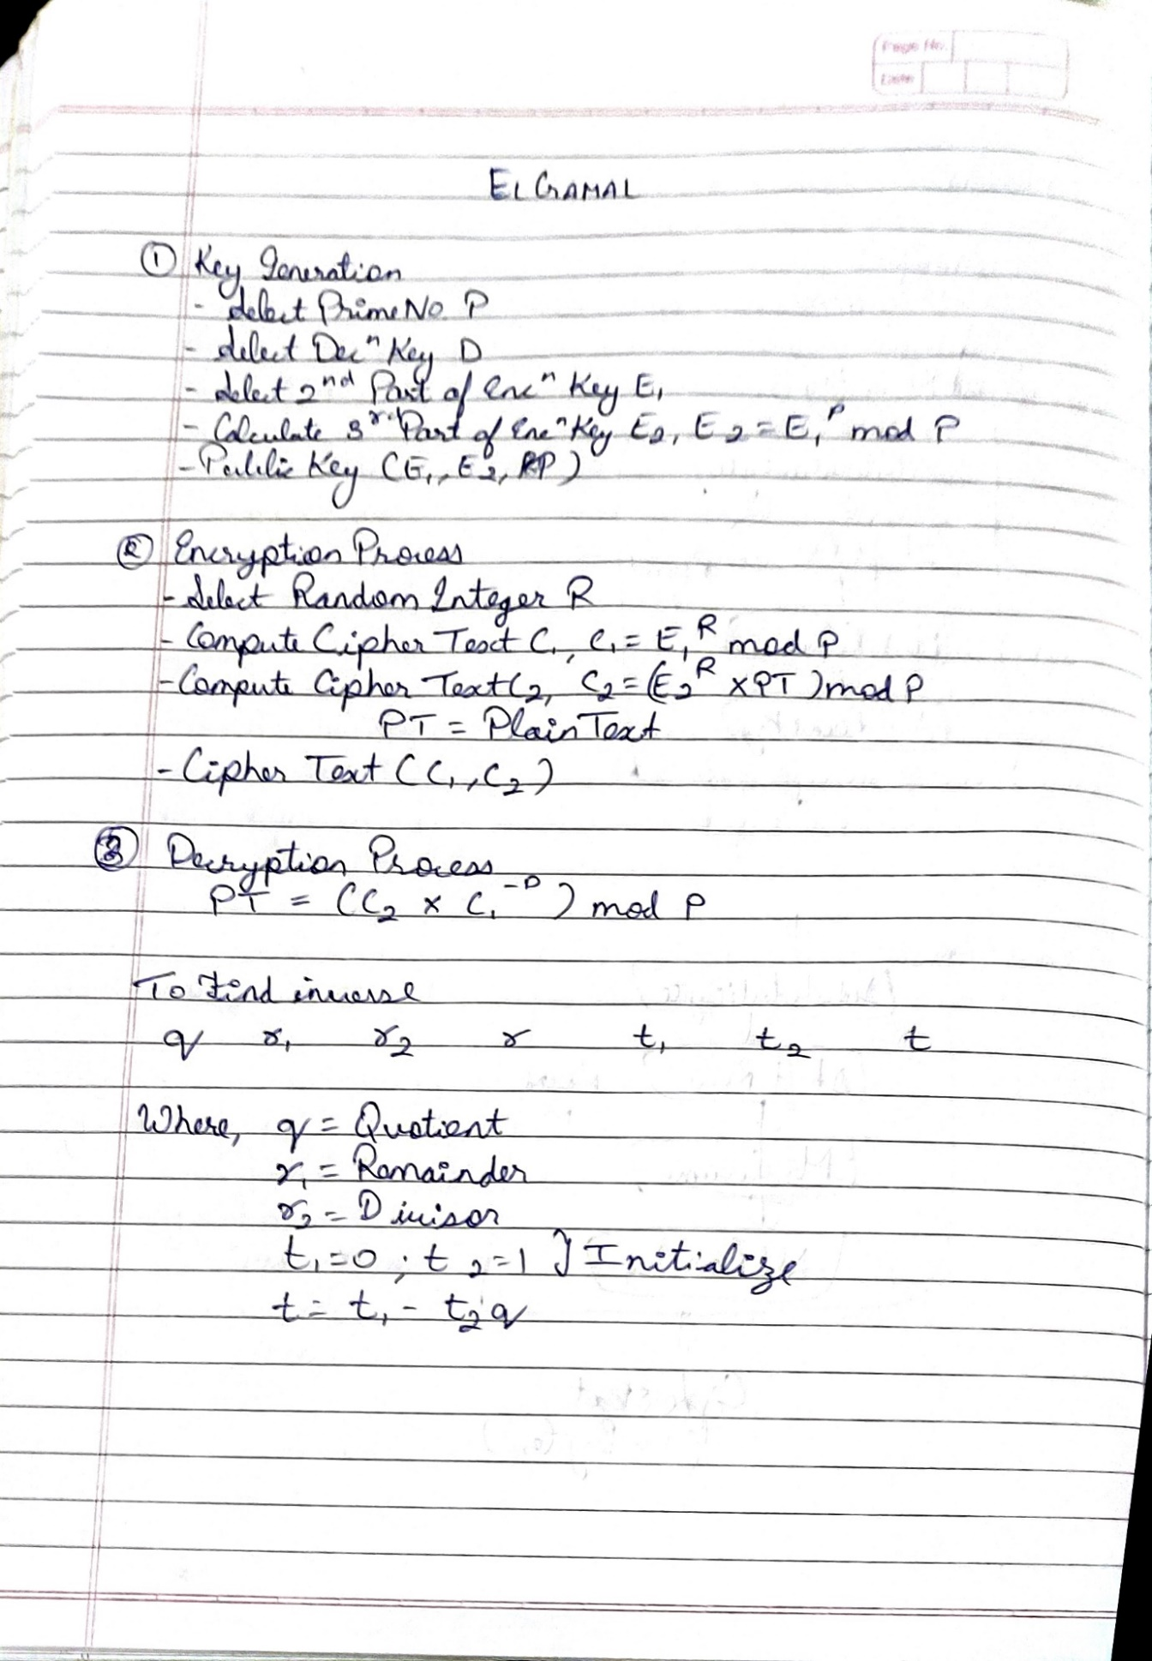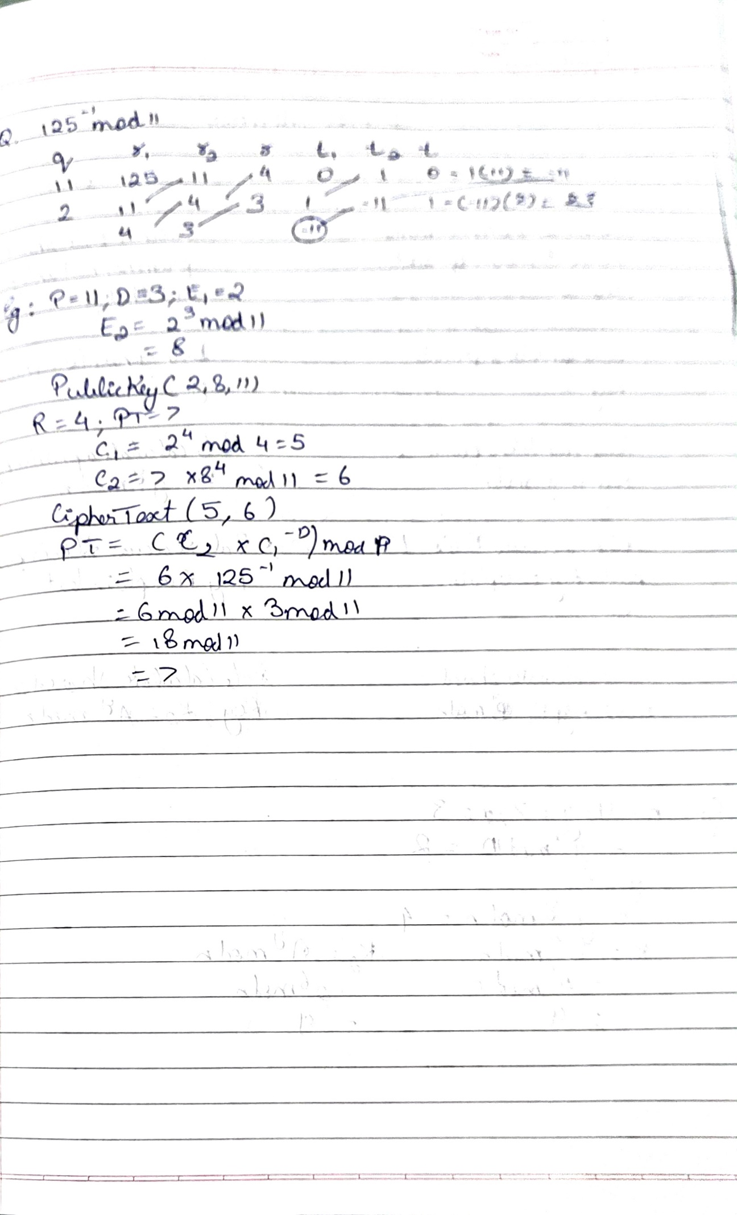

# Diffie Hellman

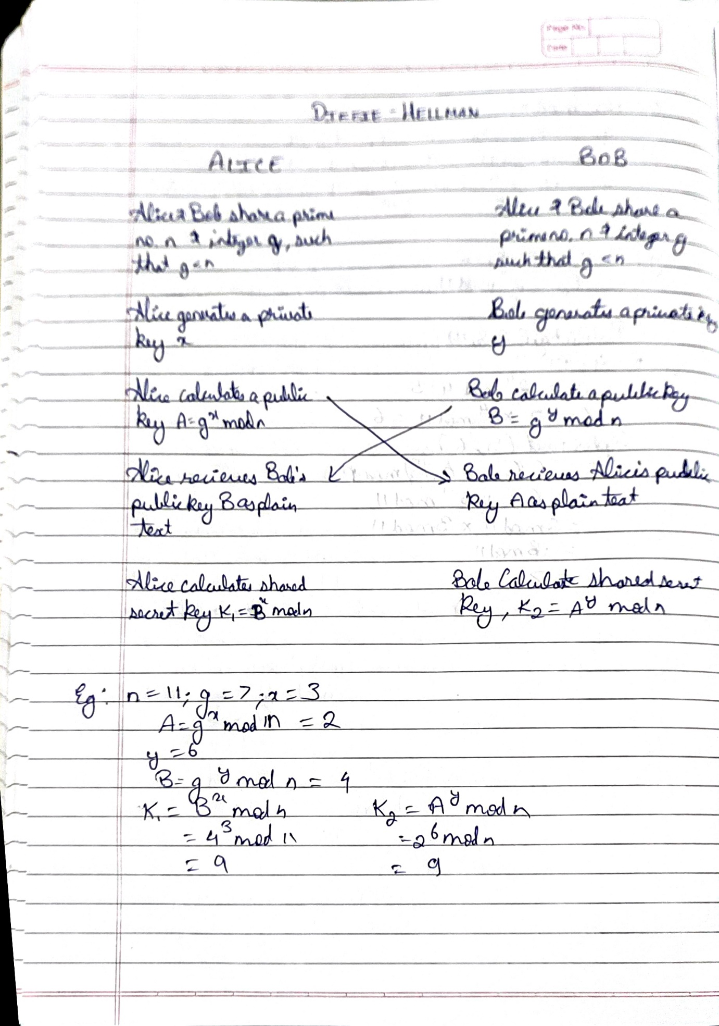

## Diffie Hellman Man in Middle

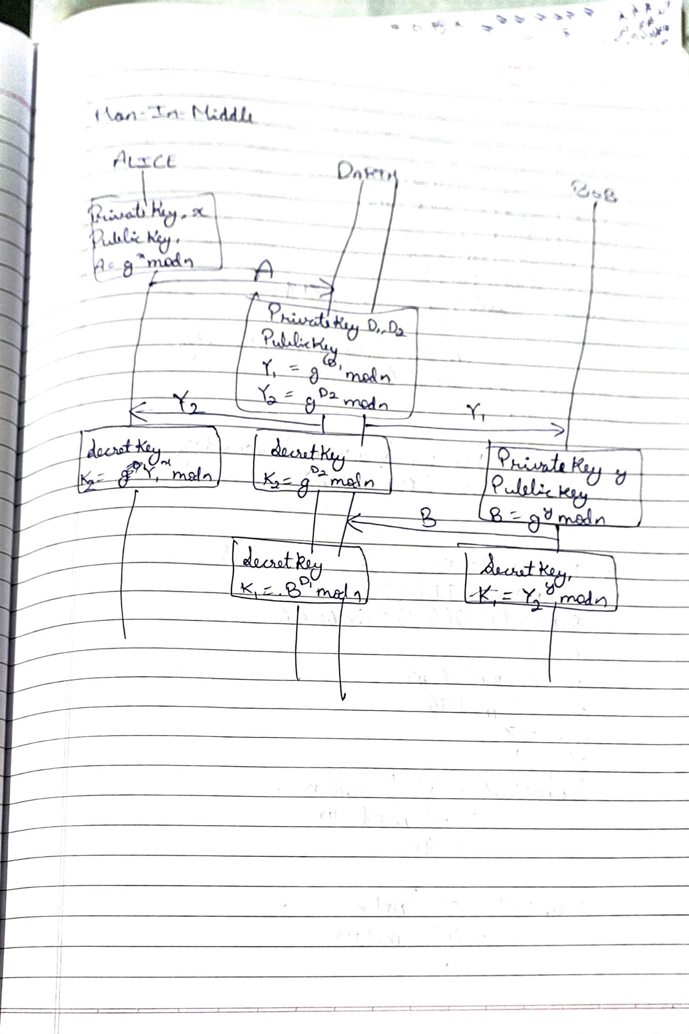

# RSA

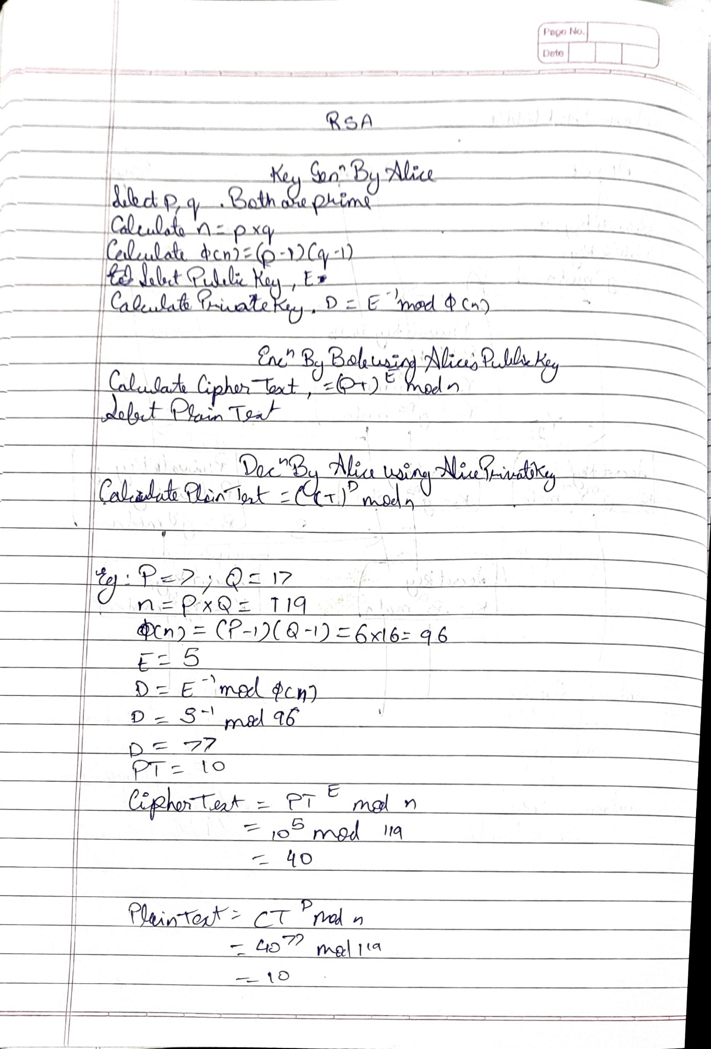

RC4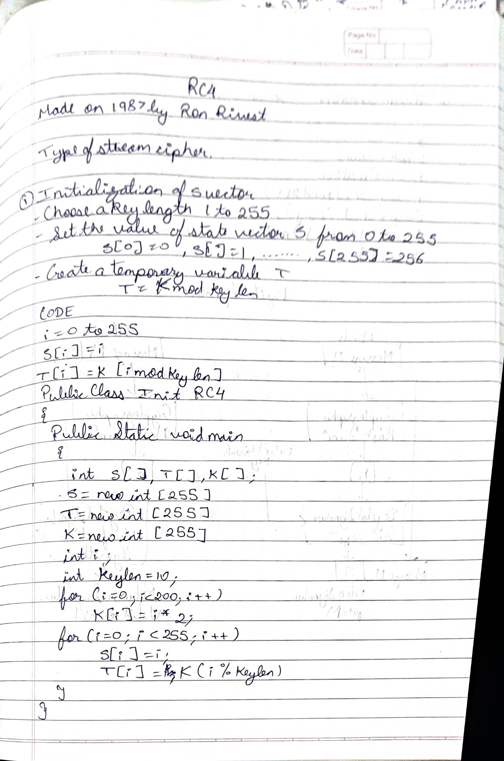

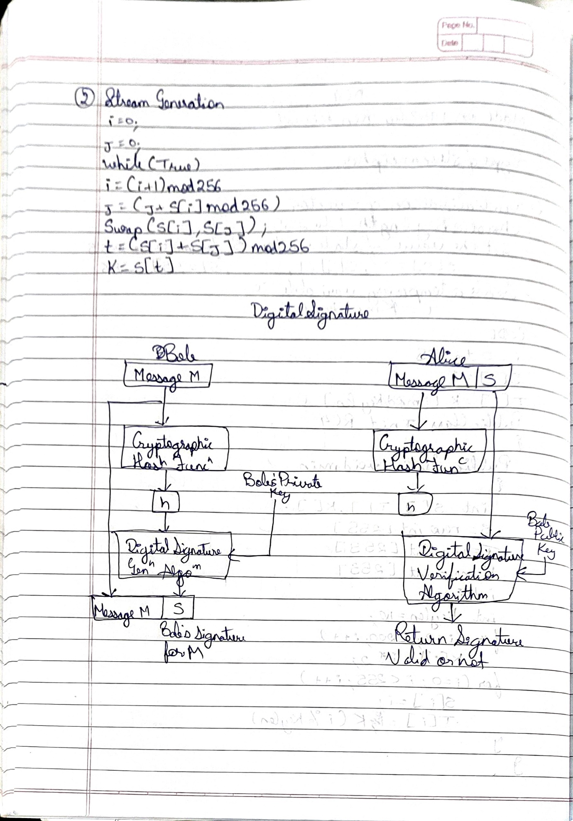

# Digital Signature

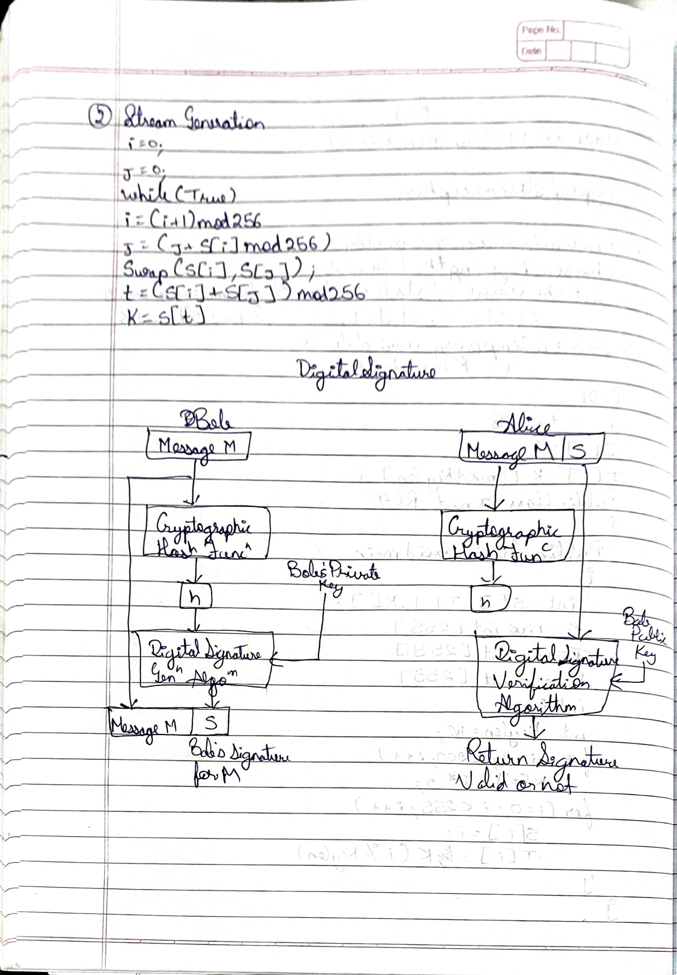

# Digital Signature Algorithm

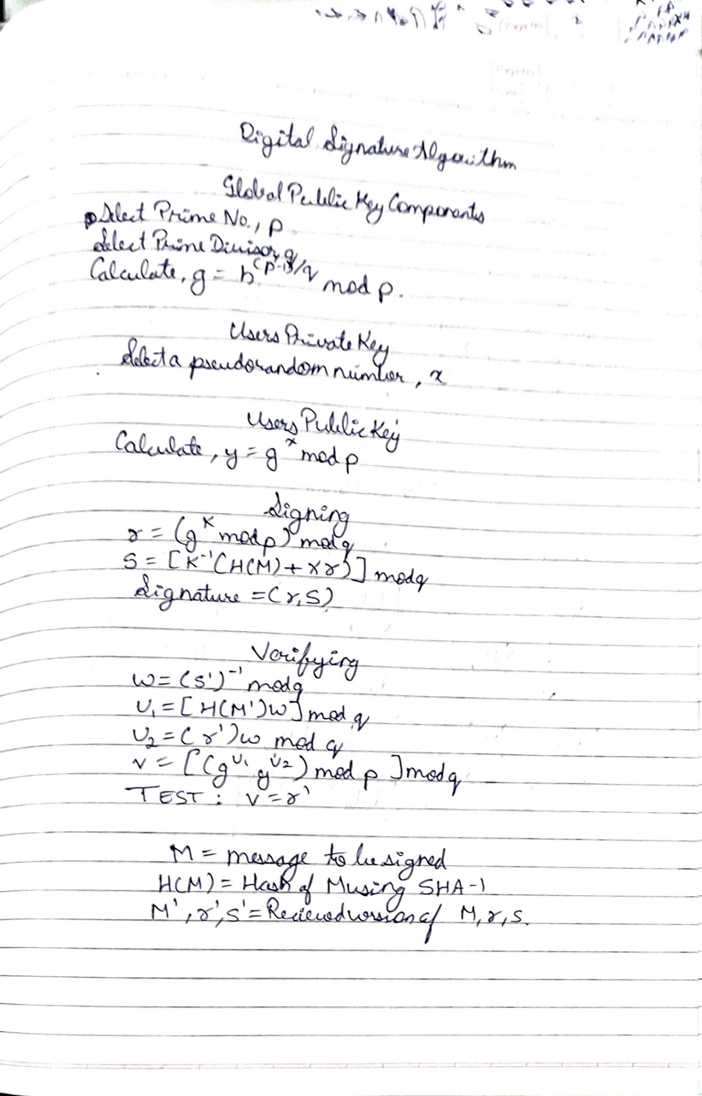

# Hash Function

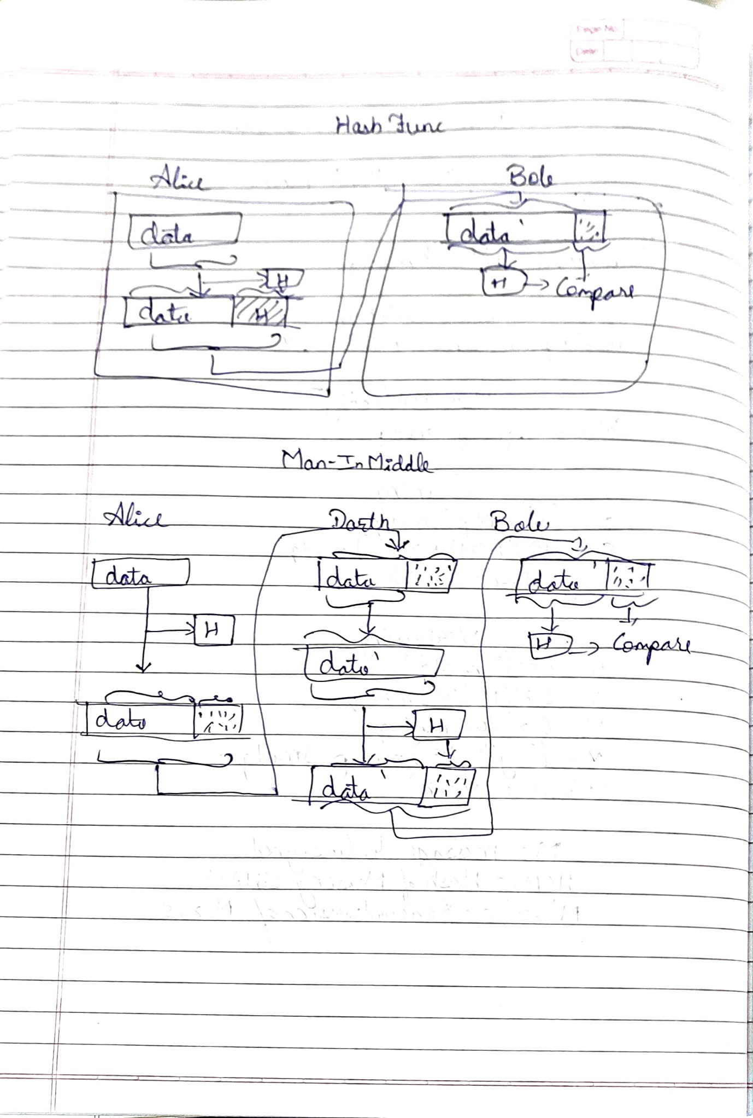

# Hash Function Man in Middle



# MD5

